Republic of the Philippines
DEPARTMENT OF EDUCATION
Region VIII (Eastern Visayas)
Division of Eastern Samar
DOLORES NATIONAL HIGH SCHOOL
Dolores Eastern Samar



COMPILATION OF DIFFERENT TYPES
AND FORMS OF CREATIVE NONFICTION

Submitted by:
Deam Shirlyn R. Tegerero

Submitted to:
Delia Navidad Tanqui-on

12-Crunos
AUTOBLOGRAPHY

My name is Deain Shirlyn R. Tegerero and I was born on May 29, 2008. My parents are Joel Tegerero and shirley Tegerero and I have a Two siblings, Julie jane Tegerero and Jopert rey Tegerero and I'm the youngest. My hobby is playing instrument like ukelele, guitar,and electric guitar, My Sibling taught me that ever before the pandemic and I've stuck with it ever since.

I'm Grade 12 student taking the HUMSS strand and I plan to pursue a degree in Criminology because I'm inspired by famele police officers who are find, helpful, and professional. I admire Their work and would love to do the same, I'm also actively involved in Dolores national high school scout this experiences have honed my critical thinking, communication and leadership stills, all of which will be invaluable in my future career, I believe that effective problem-solving requires a multifaceted approach, ore that combines academic knowledge with practical experience.

My journey is just beginning, but I'm confident that with hard word dedication, and a unwavering commitment to justice, I can make meaningful impact of the world, in just chasing a career. The yellow tape may mark the scene of a crime, but for me, it represents a starting point of a lifelong pursuit of truth and justice.
BIOGRAPHY

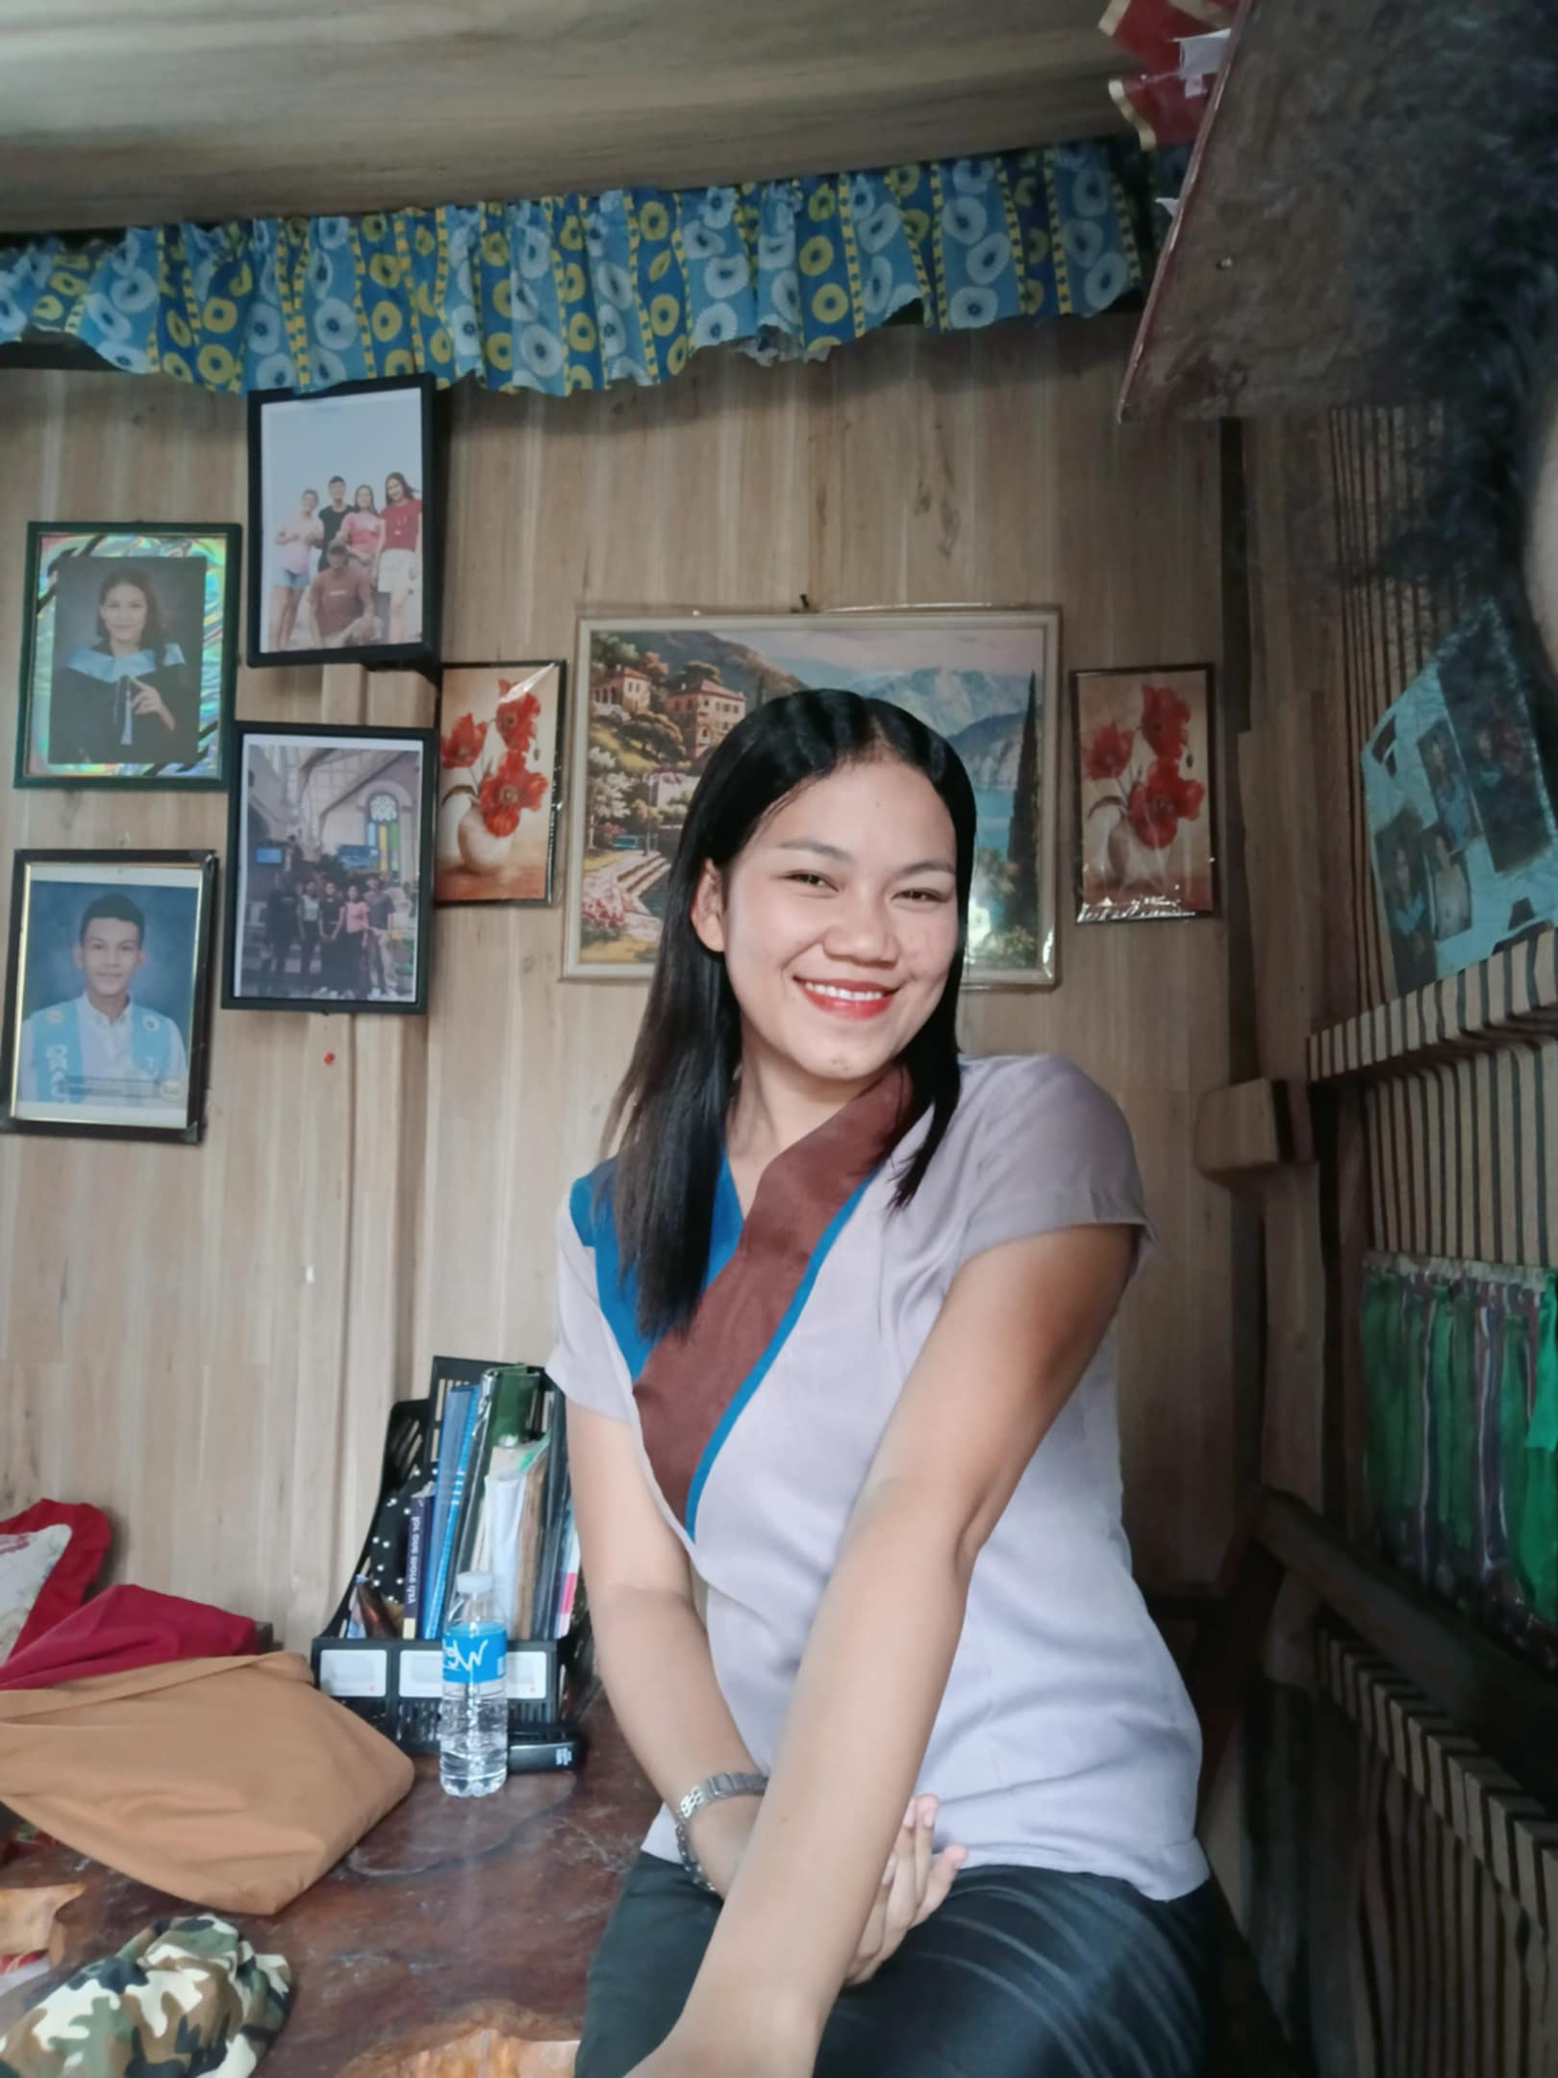

Julie Jane Tegerero is a teacher at Dolores National High School. She took up secondary education and finished her studies, achieving magna cum laude honors through her hard work, and is now a full-fledged teacher. She's the eldest among her siblings, and her parents are Joel Tegerero and Shirley Tegerero. Apart from her intelligence, she's also skilled in singing and playing the guitar.

As the eldest child of Joel and Shirley Tegerero, Julie Jane has always taken her responsibilities to heart. She’s not only a caring daughter and sister but also a natural leader and role model to her family and students alike.

Outside the classroom, Julie Jane expresses her creativity through singing and playing the guitar, talents that show her joyful and artistic side. Her warm personality, intelligence, and dedication make her someone who inspires others to follow their passions and strive for excellence.

She believes that every student has the potential to shine, and she’s committed to helping them discover that light within themselves.
TESTIMONIAL
Keratin Product


I’ve always had naturally curly hair, and it used to be dry, frizzy, and hard to manage. But after using this keratin product, my curls became softer, smoother, and more defined. It really helped reduce the frizz and made my hair easier to style every day. Now my hair looks healthy, shiny, and feels so much lighter! I highly recommend this keratin treatment for anyone with curly hair who wants smooth and beautiful results.”
PERSONAL ESSAY

When I was a child, my mom would always take me to the province to help with the harvest and planting. At first, I didn’t realize how much those moments would teach me, but looking back now, I’m thankful for them. Those days under the sun, surrounded by the fields and the hardworking people in our community, taught me the value of hard work, patience, and living simply.

Now that I’m 17 years old, I carry those lessons with me wherever I go. I’ve learned that life doesn’t have to be full of luxury to be meaningful sometimes, the simplest things bring the most happiness.

I’m currently a Grade 12 student taking the HUMSS (Humanities and Social Sciences) strand, and I’m also part of a police immersion course. This experience has opened my eyes to the importance of discipline, service, and compassion for others. It also strengthened my dream of becoming someone who protects and helps people in need.

When I reach college, I plan to take up Criminology. I want to serve others and contribute to making our community safer and better. It’s not an easy path, but I believe that with dedication, faith, and the values my family taught me, I can achieve it.

The lessons I’ve learned from my childhood working in the fields, helping my mom, and living simply shaped who I am today. They taught me to stay humble, to work hard, and to never forget where I came from. More than anything, they reminded me that success is not just about what you achieve, but about how you use it to help others.
TRAVEL WRITING
to Sulangan, Eastern Samar
Our trip to Sulangan, Eastern Samar was more than just a journey it was a spiritual and cultural experience that touched my heart deeply. The road leading there was long and winding, surrounded by tall coconut trees and lush green hills. As we traveled, I could feel the peaceful rhythm of the countryside, far from the noise of the city.

When we finally arrived in Sulangan, the first thing that caught my attention was the San Antonio de Padua Church. Its grand architecture, colorful stained-glass windows, and serene atmosphere made it truly special. Inside the church, people were quietly praying and lighting candles each one carrying faith and hope in their hearts. It is said that many devotees come to Sulangan to ask for the intercession of Saint Anthony of Padua, the patron saint of lost things and miracles.

This devotion is one of the strongest traditions in Sulangan. Every year, people from different places visit the church to offer prayers, thanksgiving, and petitions. During the town’s feast day, the community celebrates with processions, novenas, and shared meals a true display of unity and faith.

After visiting the church, we took a walk around the area. The sound of the ocean waves, the gentle breeze, and the sight of smiling locals made me feel at peace. The simplicity of life in Sulangan reminded me that happiness doesn’t come from material things but from gratitude, family, and faith.

As we left Sulangan, I looked out the window and saw the winding road again but this time, it felt different. It wasn’t just a road leading home, but a path filled with new lessons and memories. Visiting Sulangan taught me that every journey is not only about seeing new places, but also about discovering new meanings in life faith, simplicity, and togetherness.
REPORTAGE

A Young Dreamer with a Purpose: The Story of Deam Shirlyn Tegerero
In the quiet town where hard work and simplicity define daily life, Deam Shirlyn Tegerero stands as a reflection of perseverance and hope. At just 17 years old, Deam has already learned valuable lessons that many take years to understand that success begins with discipline, humility, and the willingness to serve others.
Growing up, Deam often accompanied her mother to the province to help with planting and harvesting. Those early experiences in the fields taught her how to work with dedication and appreciate life’s simple blessings. “When I was a child, Mom would always take me to the province to help with the harvest and planting,” she recalls. “Now that I’m older, I know how to live simply.”

Today, Deam is a Grade 12 HUMSS (Humanities and Social Sciences) student who is currently engaged in a police immersion program. Through this experience, she has developed a deeper understanding of discipline, service, and compassion values that have strengthened her dream of pursuing Criminology in college.

Her goal is clear: to become someone who can help others and make a difference in her community. “I want to take up Criminology because I want to help other people,” she says with determination in her voice.

Teachers and classmates describe Deam as a responsible and humble student who approaches life with quiet confidence. She is admired not only for her academic dedication but also for her strong moral values traits that she credits to her upbringing and the lessons she learned from her parents. As she prepares to take the next step toward her dream career, Deam Shirlyn Tegerero continues to inspire those around her. Her story is a reminder that even from simple beginnings, one can rise with purpose, integrity, and a heart that truly wants to serve.
EXCUSE LETTER

Date: 10-24-25

To: All teachers
Dolores National High School

Good day! Please excuse my daughter, Deam Shirlyn Tegerero, a Grade 12 HUMSS student, for her absence from class on Ocrober 24 25 She was unable to attend school due to she is not feeling well

Thank you very much for your consideration.
Respectfully yours

Guardian/Parents:
Shirley Tegerero
DIARY

Date: 10 19 25

Dear Diary,
Sometimes, I wonder why life feels so complicated. I’ve been single since birth, but honestly, I don’t mind. I chose to focus on my studies because I really want to make my family proud one day. I know that education is the key to a better future, and that’s what keeps me going.

But there are days when it gets really hard. My family often argues — there’s shouting, misunderstanding, and sometimes it feels like we don’t even listen to each other anymore. When that happens, I just stay quiet in my room, trying to understand what’s going on. I wish we could just talk calmly, laugh together, and be happy like before.

Still, I try not to lose hope. I keep reminding myself that all of this will make me stronger. Maybe the reason why I’m going through all these challenges is because they’re preparing me for something better. I just want to prove that no matter how hard life gets, I can rise above it and make my family proud.

For now, I’ll continue studying hard and believing that one day, everything will fall into place — the peace, the happiness, and the love I’ve always hoped for.

With love,
Deam Shirlyn Tegerero

MINUTES OF MEETING

THE SENIOR HIGH SCHOOL TEACHERS’ MEETING
Date: October 24, 2025
Time: 3:00 PM – 5:00 PM
Venue: Tingog Building
Presider: Manuel O. Tegerero (Principal)
Recorder: Edwin C. Galo (Secretary)

I. Attendance
Present:
Mr. Manuel O. Tegerero –Principal
Mr. Edwin C. Galo– Secretary
Mrs. Rhona C. Villanueva – Academic Track Head
Ms. Grace Dyvone T. Pomarejos – TVL Track Head
Ms. Christine Joy R. Pomida.– HUMSS Teacher
Mrs. Julie Jane R. Tegerero – STEM Teacher
Ms. Steffy B.Rebato– ABM Teacher

II. Agenda
1. Preparation for the Second Quarter Examination
2. Monitoring of Student Performance and Attendance
3. Implementation of School Activities and Programs
4. Submission of Reports and Grades
5. Other Matters
III. Discussion
1. Preparation for the Second Quarter Examination
Mr. Tegerero reminded all teachers to submit their exam questionnaires and table of specifications by October 28, 2025. The examination will be held from November 3–7, 2025.
2. Monitoring of Student Performance and Attendance
Ms. Pomarejos raised concerns about low attendance among some Grade 12 students. Teachers agreed to conduct parent consultations for students with excessive absences.
3. Implementation of School Activities and Programs
Ms. Villanueva announced that the Career Guidance Week will be on November 15–19, 2025. Teachers are encouraged to help facilitate the activities and prepare visual displays related to different college courses and careers.
4. Submission of Reports and Grades
Ms. Pomida reminded everyone to submit grades on or before November 10, 2025 to avoid delays in report card distribution.
5. Other Matters

Ms. Tegerero suggested having a short team-building activity for SHS teachers in December.
The group agreed to plan it further in the next meeting.

IV. Adjournment
The meeting was adjourned at 5:00 PM. The next meeting will be on November 8, 2025, at 3:00 PM, in the same venue.

Prepared by:
Edwin C. Galo
Meeting Secretary

